

Mahavir Education Trust’s Shah & Anchor Kutchhi Engineering College

## Report for Mini Project Titled

**“Weather Monitoring System”**

|  |  |  |
| --- | --- | --- |
| **ROLL NO** | **NAME OF STUDENT** | **DESIGNATION** |
| **17** | **VEDANT PATIL** | **MEMBER** |
| **18** | **PARTH PHODKAR** | **MEMBER** |
| **23** | **SARVESH SAWANT** | **MEMBER** |

#### **Project Guide:**

#### Prof. Santosh Kamble

**ABSTRACT**

This report illustrates the configuration of a weather monitoring system. Weather plays an important role in various fields like farming, sports, factory setup locations etc. In all these fields the sole aim is to improve the performance or improve quality of products manufactured. Hence in all these weather plays a very important role and for this we need a technology with which can monitor it from any part of the world. And with the help of IoT analyzing part can be made simpler as it provides various graph for better understanding of it and also we can monitor it from any part of the world.

**INTRODUCTION**

In the recent years the concern for climatic conditions have increased largely. Climatic changes can affect human and animal race badly hence it becomes an important task to monitor and analyze the slightest of weather changes. In this report we are presenting a system which includes sensors which helps in analyzing various factors of weather like temperature, humidity, pressure and rain. The system is based on Internet of Things (IoT) because of which when sensors senses the weather and transmits the information on web with the help of Wi-Fi connection. Because of IoT we can get live updates of weather in regular time intervals. All such technologies can widely help in improving our environment and also help in better planning of upcoming infrastructure.

**BLOCK DIAGRAM**

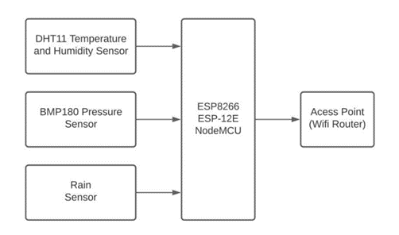

Fig 1. Block diagram of Weather Monitoring system using IoT.

In this DHT11, BMP180 and rain sensor senses the weather from the environment and sends the sensed value to NodeMCU ESP8266 and further this values are transmitted to online web with the help of an access point which is Wi-Fi Router and thus we can successfully monitor the weather.

**CIRCUIT DIAGRAM**

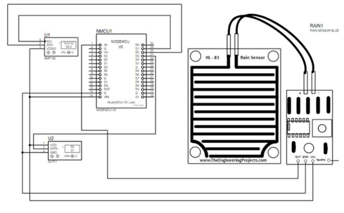

Fig. 2 Circuit diagram as simulated on Proteus software

**WORKING**

The implementation of 'Weather Monitoring System' is quite simple[2]. Firstly, the Vin of the NodeMCU ESP8266 is connected to positive(+) and Ground is connected to negative(-). The DHT11 sensor consists of three pins Vin, Out, GND. The Vin of DHT11 sensor is connected to positive(+), Out pin is of DHT11 sensor is connected to the D3 pin of NodeMCU ESP8266 and Ground pin is connected to negative(-).

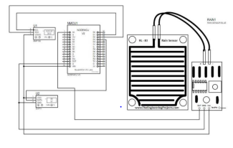

Fig. 1 Circuit diagram as simulated on Proteus software

Fig. 1 Circuit diagram as simulated on Proteus software The BMP180 sensor consists of four pins Vin, GND, SCL, SDA. The Vin of BMP180 sensor is connected to positive(+), the ground pin is connected to negative(-), the SCL pin is connected to the D1 pin of NodeMCU ESP8266 and the SDA pin is connected to D2 pin of NodeMCU ESP8266.

The Rain sensor consists of four pins Vcc, GND, D0, A0. The Vcc pin of the Rain sensor is connected to positive(+), ground pin is connected to negative(-) and the A0 pin of the Rain sensor is connected to the A0 pin of the NodeMCU ESP8266. In this DHT11, BMP180 and rain sensor senses the weather from the environment and sends the sensed value to NodeMCU ESP8266 and further this values are transmitted to online web with the help of an access point which is Wi-Fi Router and thus we can successfully monitor the weather.

**ADVANTAGES, DISADVANTAGES AND APPLICATIONS**

**ADVANTAGES:**

1. Provides diverse function and complete services.
2. Climatic data is provided in an interval of every 15 seconds.
3. Low cost and economical. Easy to use.
4. The output data is in the form of graph.

**DISADVANTAGES:**

1. The main disadvantage of an automatic weather station is that it removes the observer from the real elements being measured, and so the experience of what -5ºC temperatures or 30 knot winds feel like, is lost.

**APPLICATIONS:**

1. The weather forecasting plays very important role in the field of agriculture.
2. It is also helpful at places like volcano and rain forests.
3. It is quite difficult for a human being to stay for longer time at such places.

**FUTURE SCOPE**

This sensor has following future scopes of implementation:

1. Smart Agriculture System
2. Home Automation System
3. Face Recognition Bot
4. Smart Garage Door
5. Smart Alarm Clock
6. Air Pollution Monitoring System
7. Smart Parking System

**RESULT**

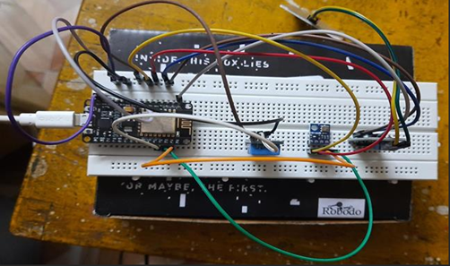

Fig 3. Weather monitoring system module

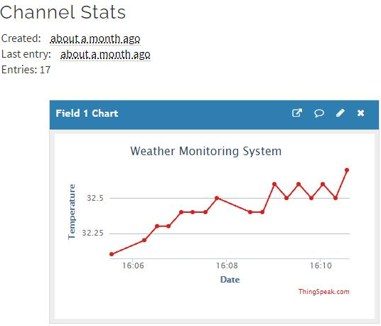

Fig 4. Temperature Measurement

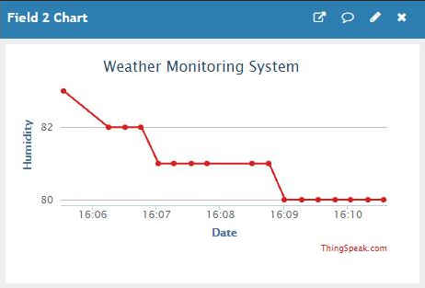

Fig 5. Humidity Measurement

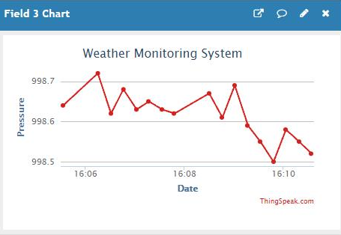

Fig 6. Pressure Measurement

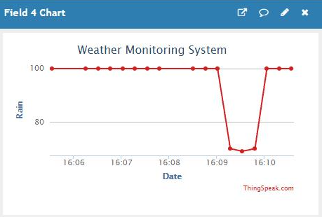

Fig 7. Rain Measurement

Fig 3. Shows the hardware implementation part of the Weather Monitoring system. Fig 4, Fig 5, Fig 6, Fig 7, Depicts the graphs obtained on ThingsSpeak Window of temperature(in °C), humidity(in %), pressure(in mbar) and rain(in analog value) repectively.

**CONCLUSION**

Although science and technology have developed and evolved a lot, but availability of data anywhere and anytime still remains a issue. In order to address issues like this IoT technology can contribute largely and efficiently. When we keep weather station out in the environment the various sensor devices used collect the data from the environment and slowly within certain time we can observe the graph getting updated on ThingsSpeak window.

This model can also be expanded in order to make it available for large scale applications like putting such systems in emerging cities and industrial areas for monitoring various weather factors.